Creality CR-10 - 300*300*400mm Printing Size 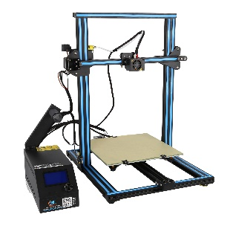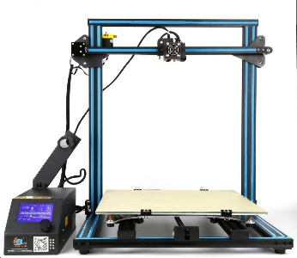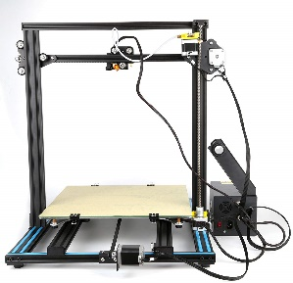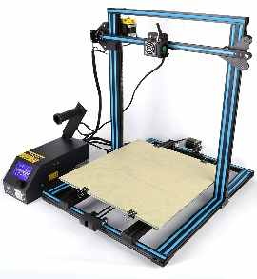

Specifications
Printing size | 300*300*400mm
Printing type | FDM (Melting touch stack molding technology)
Body structure | Patent technology V-Slot aluminum bearing
Nozzle diameter | Default 0.4mm, one 0.3mm nozzle for free
Filament diameter | 1.75mm
Plug | Default EU plug  (the CN warehouse will ship the adapter together)
Print speed | ≤200mm / s, normal printing speed: 100mm / s
Each accuracy | 0.05-0.4mm (adjustable)
Power supply | Input 110-220V switchable, output 12V
Actual power | 160-200W
Operating page | Chinese / English
Printing accuracy | ±0.1mm
Environmental requirement | 10-30°C, humidity 20-50%

Parameter
Materials | PLA, ABS, TPU, Copper, Wood, Carbon Fiber, Gradient Color etc.
Software supporting | PROE, Solid-works, UG, 3d Max, Rhino 3D design software, etc.
Format | STL, OBJ, G-Code, JPG
Printing method | SD card(off-line), contact to the PC(on-line)
Operating system | Linux, Windows, OSX
Operating software | CURA, Repetier-Host, simplify 3D
Machine size | 490*600*615 mm
Package size | 540*640*310 mm
Machine net weight | 10.3kg
Package weight | 14kg

